**ELECTRONICS AND COMMUNICATION ENGINEERING**

**Descriptions, terms and conditions of competitive events**

|  |  |  |  |  |  |  |
| --- | --- | --- | --- | --- | --- | --- |
| **SL.NO** | **EVENT** | **Ist Prize** | **2nd Prize** | **3rd Prize** | **EXPENSES** | **TOTAL** |
| 1 | Best Manager | 8,000 | 4,000 | nil | 6,000 | 18,000 |
| 2 | Robopuglism | 12,000 | 8,000 | 5,000 | 4,000 | 29,000 |
| 3 | BURN OUT | 12,000 | 8,000 | 5,000 | 4,000 | 29,000 |
| 4 | Circuitrix | 8,000 | 5,000 | 3,000 | 100 | 16,100 |
| 5 | MatlabProfizia | 8,000 | 5,000 | 3,000 | 100 | 16,100 |
| 6 | Project presentation | 10,000 | 5,000 | 3,000 | 100 | 18,100 |
| **GRAND TOTAL** | | | | | | 1,26,300 |

**1.ROBO PUGILISM-Robo War**

First Prize: Rs.12, 000/-

Second Prize: Rs.8, 000/-

Third prize: Rs.5, 000/-

Event manager:SANTHI KUMAR

Mobile:7293646756

Event coordinator:ASWIN BALACHANDRAN

Mobile:9495577233

#### INTRODUCTION

War has been in human blood from times immemorial. The arena is all set and ready in one of the most highlighted events in Agnitus :Robo Pugilism. Unleash the destructive power of your bot, and where oppugnancies’ becomes reencounter, metal blood will drop in the ring.

**SPECIFICATION OF THE ROBOT**

Weight: 10kg

Dimensions (l*b*h):50cm x 50cm x 40cm

Power supply: 24 Volts

**ROUNDS**

**1) ELIMINATION**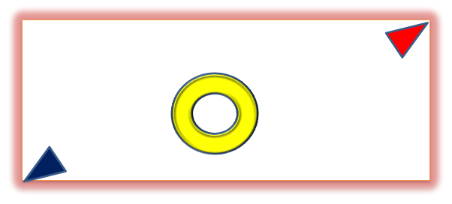

* Arena size 3.6m x 2.4m
* The event will involve single round 5 minute matches with intervals of 2 minutes.
* Scoring will depend on the following:
* Wireless robots will get a bonus of 70pts
* Pushing opponents out of the arena will get 50pts
* Immobilizing the opponent(15sec count) will get 30pts
* In case of a tie, there will be a 1min tie breaker.
* Group winner will be elected based on the following criteria:
  1. The winner will get 10pts
  2. Both the teams in a tie match will be awarded 3pts, and the winner will be awarded an additional 3pts

**2) KNOCK OUT ROUND**

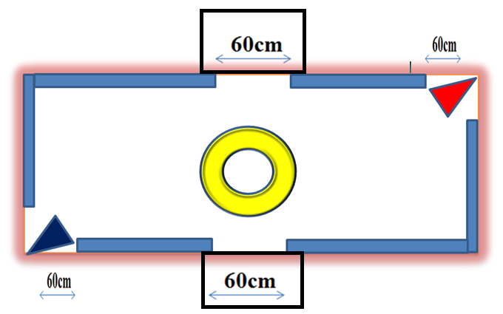

* The match will be conducted in a modern arena with four exits
* Among the four openings, the two side openings will lead to a springe
* A match will consist of 3 rounds of 3 minutes each
* There will be a 1 minute interval between rounds
* Corner opening will be open at all times
* Side openings will open every 20 seconds. Pushing opponents to the springe will be awarded additional points.
* Scoring will be done based on the following criteria:
* Wireless robots will get a bonus of 70pts
* Pushing opponents out of the arena will get 50pts
* Pushing opponents to the springe will get 100pts
* Pushing opponents out of the arena through the corner openings will get 100pts
* Immobilizing the opponent(15sec count) will get 30pts
* In case of a tie, there will be a 1min tie breaker.

RULES AND REGULATIONS

* There will be a maximum of 5 members in a team.
* Decision of Judges will be final and if necessary they have the authority to change the rules.
* Agnitus programme committee will take have the supreme authority to take final decisions.
* Any number of teams can participate from a college. Cross-college teams are also allowed.
* Agnitus programme committee will not be responsible for any losses or harm occurring during participation.
* Violating the rules and damaging the college property will attract penalty and permanent disqualification.
* Weight and dimensions of the robot will measured at the beginning of each match. Tolerance at each stage is 5%.
* Once the weight and dimensions are noted it will be considered permanent during the whole tournament.
* Changing of motor or other circuit parts will be allowed only if break down occurs. Alteration of shape will not be encouraged.
* No of rounds will depend upon the number of participants.

**2.BEST MANAGER**

First Prize: Rs.8,000/-

Second Prize: Rs.4,000/-

Event manager:ADITHI PRAKASH

Mobile:9895769146

Event coordinator: VINEETH C.M

Mobile: 9562470503

#### INTRODUCTION

Civilisation has always demanded individuals with impeccable managerial skills. If you have got it in you to blow us away with your talents, the kaleidoscope is waiting for you at Agnitus.

**RULES AND REGULATIONS:**

**THIS IS A SOLO EVENT AND COMPRISES OF 4 ROUNDS:**

**ROUND 1: (PRELIMS)**  
• The preliminary written test will consist of a 30 minute objective question round. 

**ROUND 2: (MULTI TASKING)**  
• Each participant will be given a topic on-spot.   
• A clip of audio-visual will be displayed simultaneously.   
• The idea is that the topic, audio and video will be totally unrelated and the participant has to create a flow of thoughts between them and talk about it.   
• Participants will be given a preparation time of 1 min and an elocution time of 2 minutes.

**ROUND 3: (AD-ZAP)**  
• This is a marketing round. It will test the person's ability to convince people, his managerial skills and cleverness..   
• The selected participant will have to market a worthless product to an irrelevant person.   
• He/she will be given 1 min preparation time and 3 min to market the product.   
• A total of 6 participants will be selected for the next round.

**ROUND 4: (STRESS INTERVIEW)**  
• Three participants shortlisted for the final round will be undergoing some sort of stress interview which would test power management, tolerance and patience.   
• Time is variable.   
• The best surviving participant will be named as the "BEST MANAGER" of Agnitus 2k14.

**3.MATLAB PROFIZIA-MATLAB PROGRAMMING**

First Prize: Rs.8, 000/-

Second Prize: Rs.5, 000/-

Third prize: Rs.3, 000/-

Event manager:ARJUN P A

Mobile:7736828076

Event coordinator:ANUGRAH PRAKASH

Mobile:9633983765

INTRODUCTION

The motive behind every single designing software ever developed is to make things simple. Let’s take a turn here. Matlab Profizia aims at making simple things complex. Agnitus provides you a golden arena to prove your proficiency and mettle in MATLAB.

RULES

* There will be a maximum number of two members in a team.
* There will be an initial 20 minute elimination round with objective questions.
* This will be followed by a 1 hour programming session wherein participants have to develop a particular programme as advised.
* The prize money depends on the level of achievement. i.e. Only a 100% solution will achieve the full amount.
* Decision of Judges will be final and if necessary they have the authority to change the rules.
* Agnitus programme committee will take have the supreme authority to take final decisions.
* Any number of teams can participate from a college. Cross-college teams are also allowed.
* Agnitus programme committee will not be responsible for any losses or harm occurring during participation.
* Violating the rules and damaging the college property will attract penalty and permanent disqualification.

**4.PROJECT PRESENTATION**

First Prize: Rs.5, 000/-

Second Prize: Rs.3, 000/-

Third prize: Rs.2, 000/-

Event manager:ROMA A P

Mobile:9747681030

Event coordinator:SANAHA SHYAM

Mobile:7736131673

INTRODUCTION

Have that ever-innovative idea that can bring about quakes in the techno-world? The podium awaits you.

RULES

* Project idea should be relevant in field of **Electronics and communication**
* There will be a maximum number of five members in a team.
* Participants should send their project synopsis including the block diagram, detailed working and area of application etc. to [agnitus2k14@gmail.com](mailto:agnitus2k14@gmail.com)
* In case of more than 15 entries elimination will be done based on te following criteria:

1. Feasibility of the project
2. Technology used for implementation

* Selected entries will be informed.
* Selected 15 entries should attend the viva-voce session with the working model and with a presentation of not more than 50 slides.
* Scoring will be based on:

1. Knowledge about the model.
2. Feasibility of the project
3. Technology used for implementation
4. Decision of Judges will be final and if necessary they have the authority to change the rules.
5. Agnitus programme committee will take have the supreme authority to take final decisions.
6. Any number of teams can participate from a college. Cross-college teams are also allowed.
7. Agnitus programme committee will not be responsible for any losses or harm occurring during participation.
8. Violating the rules and damaging the college property will attract penalty and permanent disqualification.

**5. BURN OUT**

First Prize: Rs.12,000/-

Second Prize: Rs.8,000/-

Third prize: Rs.5,000/-

Event manager:NAZIF NAZ K N

Mobile: 9746646960

Event coordinator:PARVAN PAVITHRAN

Mobile:9995904484

INTRODUCTION

The track is laid. The flags are waving. The gun is ready. Agnitus invites you to the ultimate round of burning rubber, screeching tires and thundering applause - Burnout 2k14.

SPECIFICATIONS:

* Maximum size of car: 30*30*30 cm.
* Car has to be self-powered ( max 15V).
* The car has to be entirely controlled by keyboard/joystick.
* Keyboard has to be connected to a RF Transmitter.
* The system should support a minimum of two frequencies.
* The car must have a RF receiver.
* The car should be able to steer and move in both directions and brake.
* Kits except receiver and transmitter cannot be used in the bots.
* The track will be 50 cm wide.
* Obstacles will include
* Mazes
* Dirt, clay, sand,etc.
* Water pools (5cm deep).
* Ring roads with humps and pits.
* Surprise track!

RULES:

* There will be a maximum of 4 members in a team
* Decision of Judges will be final and if necessary they have the authority to change the rules.
* Agnitus programme committee will take have the supreme authority to take final decisions.
* Any number of teams can participate from a college. Cross-college teams are also allowed.
* Agnitus programme committee will not be responsible for any losses or harm occurring during participation.
* Violating the rules and damaging the college property will attract penalty and permanent disqualification.
* Changing of motor or other circuit parts will be allowed only if break down occurs. Alteration of shape will not be encouraged.

**6. CIRCUITRIX**

First Prize: Rs.8,000/-

Second Prize: Rs.5,000/-

Third prize: Rs.3,000/-

Event manager:VARUN B

Mobile:8129832037

Event coordinator:NIVIN D’CRUZ

Mobile:9633384558

Intro

Circuitrix is all about team work, intellect, patience and speed. This thrilling task delves into the world of tricky electronic circuitry wherein the participants are required to find out hidden faults in the given electrical circuit, and complete the different assigned tasks in the least possible time.

PROCEDURE:

This is group event comprising of three rounds:

**ROUND 1: (PRELIMS)**  
• The preliminary written test will consist of a 30 minute objective question round.

**ROUND 2: CONTRIVANCE D’CIRCUITOS**

The participants must design a circuit as per the specifications given and successfully simulate it in Proteus within a time limit of 45 minutes.

**ROUND 3: STUMBLE CIRCUTOZ**

An error circuit is to be corrected in a time limit of 30 minutes and successfully simulated in Proteus.

RULES:

* Participants must have sufficient knowledge in working with Proteus (simulation software).
* There will be a maximum of two members in a team.
* The prize money depends on the level of achievement. i.e. Only a 100% solution will achieve the full amount.
* Decision of Judges will be final and if necessary they have the authority to change the rules.
* Agnitus programme committee will take have the supreme authority to take final decisions.
* Any number of teams can participate from a college. Cross-college teams are also allowed.
* Agnitus programme committee will not be responsible for any losses or harm occurring during participation.
* Violating the rules and damaging the college property will attract penalty and permanent disqualification.